Among 5 Devices - Amazon Kindle Fire HDX 7, LG G Pad, Samsung Galaxy S5, Samsung Galaxy S6 and Samsung Galaxy Tab 4, only Amazon Kindle Fire HDX 7 and Samsung Galaxy S6 completed all three tests. The other three passed 2 of 3 tests.

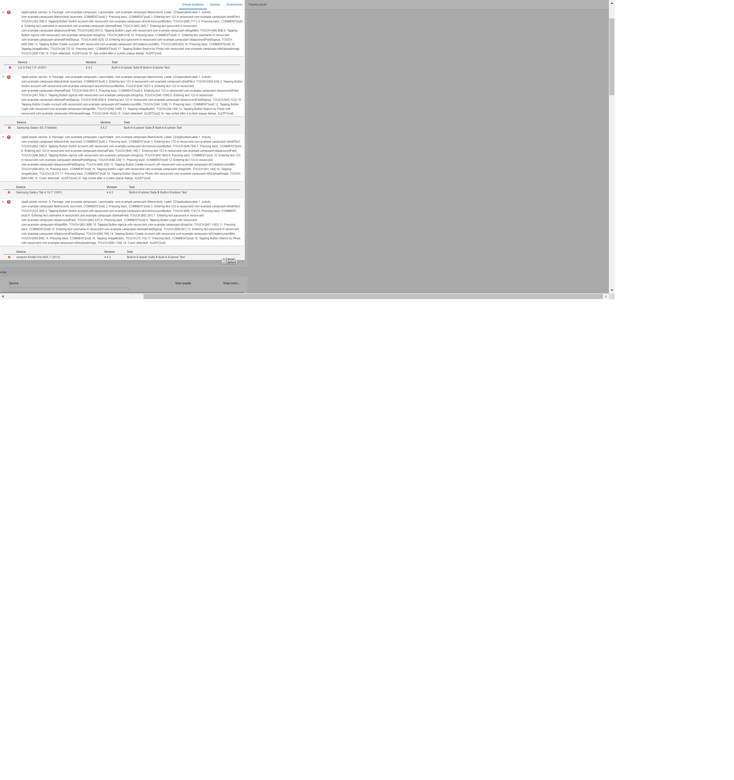

All these 4 crashes seem like one bug, that you should choose one picture from your local galary, and then press the search by photo button. It crashed when press the button before choosing a picture. However, it still shouldn’t crash, since we can always pop up some warning information if you do so.